RSCD/KLK/RRT/JAE/vdl Mailed 10/12/01

Decision 01-10-012 October 10, 2001

BEFORE THE PUBLIC UTILITIES COMMISSION OF THE STATE OF CALIFORNIA

Application of the Santa Clara Valley Transportation Authority for an order authorizing construction of an at-grade crossing of the Woz Way/West San Carlos Street Intersection (82D-2.5) by the light rail transit line of the Vasona Light Rail Project in the City of San Jose, County of Santa Clara. | Application 01-03-034  (Filed March 20, 2001)

OPINION

Summary
Santa Clara Valley Transportation Authority (VTA) requests authority to construct an at-grade crossing of the Woz Way/West San Carlos Street Intersection by the light rail transit line of the Vasona Light Rail Project in the City of San Jose, Santa Clara County.

Discussion
VTA was created as a County department by the Santa Clara County Board of Supervisors on June 6, 1972 to oversee the region’s transportation system. VTA’s primary responsibility since its creation has been the development, operation and maintenance of the bus and light rail system within the County. VTA separated from the County of Santa Clara and merged with the region’s Congestion Management Agency in January 1995; thereby it gained the additional responsibility of managing the County’s blueprint to reduce congestion and improve air quality.
The Vasona Light Rail Project will be an extension to the existing 28.6-mile VTA light rail system (see Appendix A). The alignment of the proposed Vasona Corridor extends from downtown San Jose to the Vasona Junction in the City of Los Gatos. The northerly terminus of the alignment is at the intersection of West San Carlos Street and Woz Way in downtown San Jose, where the Vasona line connects to the existing Guadalupe Corridor line. From this point, the alignment extends to the west along West San Carlos Street to Delmas Avenue, passing under the SR-87 overpass. The LRT line extends north along the east side of Delmas Avenue to San Fernando Street, at which point the alignment turns west again. The line continues to the San Jose Diridon Station on an alignment to the north of San Fernando Street, crossing Los Gatos Creek on a proposed new bridge. The segment west of Autumn Street, including the location where the LRT line crosses the existing UPRR and PCJPB Diridon Yard tracks, is underground. After crossing under the yard tracks at the San Jose Diridon Station, the alignment returns to the surface and heads in a southerly direction along the west side of the Diridon Yard tracks. From a point just south of Park Avenue, the proposed alignment utilizes the existing Vasona railroad corridor. The project remains within the railroad corridor all the way to the Vasona Junction in the City of Los Gatos. Existing freight rail service in this corridor will continue unchanged, although the existing single track will be relocated in many areas to allow for construction of the light rail transit tracks.
The proposed project is expected to be funded in three phases. Phase 1 constructs the portion of the project from downtown San Jose to the Downtown Campbell Station. Phase 2 extends the line from Downtown Campbell Station to the Winchester Station. Phase 3 extends the line from Winchester Station to the Vasona Junction Station in the City of Los Gatos.
The light rail transit tracks will cross the Woz Way/West San Carlos Street Intersection at-grade. The at-grade crossing is the most financially and environmentally acceptable choice and is in keeping with the open access concept of light rail transit. Alternatives to an at-grade crossing are depressing the street below the tracks, depressing the tracks below street level, elevating the street above the tracks, and elevating the tracks above street level. Each of these alternatives may be physically impossible. Other problems would also be created with a grade separated crossing, such as conflicts with existing development and utilities, noise generation, aesthetic impacts and the creation of possible hazards due to flooding caused by depressing rail or street facilities. Construction of this project serves the public by providing efficient transportation in a growing area of the Santa Clara Valley.
VTA is the lead agency for this project under the California Environmental Quality Act of 1970 (CEQA), as amended, Public Resources Code Section 21000, et seq. A Draft Environmental Impact Report (EIR) for the Vasona Corridor Light Rail Transit Project was released to the public in October 1999, beginning the formal review period. VTA prepared a Final EIR/Final Environmental Impact Statement (EIS) in March 2000 in accordance with CEQA and the National Environmental Policy Act (NEPA). The EIS/EIR evaluated the proposed rail transit project and several options. Public scoping meetings were held on April 14-15, 1999, at which meetings, the light rail project was discussed at length with local citizens in the surrounding communities. In addition, there had been previously a period of public comment wherein local citizens were asked to write in their comments and concerns regarding impact on their properties or other pertinent matters. Comments by the public, where feasible, were incorporated into the environmental documents and considered in the preparation of the EIS/EIR of the Light Rail Corridor.
On May 4, 2000, a Notice of Determination (Notice) was filed with the State Secretary of Resources - Office of Planning and Research, Sacramento and the County Clerk Recorder's Office - Santa Clara County, City of San Jose. The Notice, which is included in Appendix C, advised all interested parties that the VTA was in compliance with Section 21108 of the California Public Resources Code.
VTA has approved the proposed project, as the environmentally superior alternative, and further stated that:
- The project will not have a significant effect on the environment.
- A Final EIR was prepared for this project pursuant to the provisions of CEQA.
- Mitigation measures were made a condition of the approval of the project.
- A Statement of Overriding Considerations was not adopted for this project.
- Findings were made pursuant to the provisions of CEQA.
A certification was made that the Final EIR with comments, responses and record of the project approval was made available to the general public at the Environmental Analysis, Building B in the City of San Jose on May 5, 2000.
The Commission is a responsible agency for this project under CEQA (Public Resources Code Section 21000 et seq.). CEQA requires that the Commission consider the environmental consequences of a project that is subject to its discretionary approval. In particular, to comply with CEQA, a responsible agency must consider the lead agency’s EIR or negative declaration prior to acting upon or approving the project (CEQA Guideline Section 15050(b)). The specific activities that must be conducted by a responsible agency are contained in CEQA Guideline Section 15096. The site of the proposed project has been inspected by the Commission’s Rail Safety and Carriers Division – Rail Crossings Engineering Section staff. Staff examined the need to construct the proposed crossing, as indicated in the exhibits attached to the application, and recommends that the application be approved.
The Commission has reviewed the lead agency environmental documents. The EIS included an analysis of potential environmental effects, including impacts related to transportation and traffic, air quality, noise and vibration, energy, land use, socio-economics and environmental justice, vegetation and wildlife, water quality, floodplains, geology, hazardous materials, magnetic fields and interference, cultural resources, aesthetic considerations, safety and security, construction and growth-inducing impacts.
The EIS analyzed 35 potential environmental impacts. Of that number, 17 were found to have no effect, be not substantial, potentially beneficial or beneficial; 18 were found to have potentially substantial or substantial effects. However, mitigation measures were adopted and will be implemented as specified by the lead agency to either eliminate or substantially lessen those environmental impacts. In particular, we have considered the following information.
The proposed project will reduce overall vehicle-miles-traveled (VMT) and vehicle-hours-traveled (VHT) in Santa Clara County. Reducing traffic congestion will also reduce auto emissions that degrade air quality. This is a beneficial impact because a decrease in VMT and VHT reduces congestion, air pollution and energy consumption.
Noise due to moving trains will exceed Federal Transit Administration (FTA) thresholds at various residences located along the alignment. The noise impacts will be mitigated with the construction of soundwalls, reducing the impacts to a less-than-significant level.
Socio-economic impacts will be less than significant, as the project will not result in disproportionate impacts to minority or low-income populations. No neighborhoods will be divided and no cultural or religious facilities will be impacted by the project.
The proposed project will not result in significant air quality impacts. In fact, the project is anticipated to result in a beneficial impact on regional air quality. Furthermore, the proposed project conforms to the requirements of the federal Clean Air Act.
The project will provide opportunities for joint development at various locations. Joint development, sometimes referred to as Transit-Oriented Development has overall beneficial land use impacts because it allows for high-density infill with easy transit access.
The proposed project will not result in significant long-term water quality impacts. However, the proposed project could result in significant short-term water quality impacts during construction. The short-term impacts would be reduced to a less-than-significant level by the specific construction practices and methods being utilized.
As to each of the potentially substantial or substantial impacts identified in the EIS and as discussed above, the Commission finds the lead agency adopted feasible mitigation measures to either eliminate or substantially lessen the impacts.
Protection at the crossing shall be as indicated by text, plans attached to the application and as further described by Appendices A and B of this order.
The application was found to be in compliance with the Commission's filing requirements, including Rules 38-41 of the Commission's Rules of Practice and Procedure. Site maps of the grade crossing are as shown on plans attached to the application and Appendix A.
In Resolution ALJ 176-3060, dated March 27, 2001 and published in the Commission Daily Calendar on March 28, 2001, the Commission preliminarily categorized this application as ratesetting, and preliminarily determined that hearings were not necessary. Since no protests were filed and no hearings were held, this preliminary determination remains accurate. The Commission’s Rail Safety and Carriers Division recommends that this application be granted. Given these developments a public hearing is not necessary, and it is not necessary to disturb the preliminary determinations made in Resolution ALJ 176-3060.
This is an uncontested matter in which the decision grants the relief requested. Accordingly, pursuant to Public Utilities Code Section 311(g)(2), the otherwise applicable 30-day period for public review and comment is being waived.

Findings of Fact
- Notice of the application was published in the Commission Daily Calendar on March 22, 2001. There are no unresolved matters or protests; a public hearing is not necessary.
- VTA requests authority to construct an at-grade crossing of the Woz Way/West San Carlos Street Intersection by the light rail transit line of the Vasona Light Rail Project in San Jose, Santa Clara County.
- Construction of the proposed project is an essential element in the construction of the Vasona Light Rail Extension Project. The project is required in order to provide quality and accessible public transportation system in the Vasona/Highway 17 Corridor area within the Cities of San Jose, Campbell and Los Gatos. The goal is to construct a system that is convenient, is integrated with other rail and bus service, and which minimizes environmental effects on existing land uses to the extent practical. The benefits of the project include a reduction in automobile trips, improvements in air quality and a reduction in energy usage.
- Santa Clara County, referred to as Silicon Valley, contains many high-tech companies from other nations. The growth of that industry has resulted in substantial increases in jobs and population in the County, and such growth is projected to continue.
- The substantial growth and development that has taken place in Santa Clara County during the last decades has caused transportation system deficiencies in the Vasona Corridor, as well as throughout the County. To address the resulting increase in traffic demand on the County's transportation system, a comprehensive transportation plan was established. The plan identified the future deficiencies in the County's transportation system by identifying the planned transportation system improvements in relation to the existing need and anticipated population growth. One of the conclusions of the plan was that the Vasona Corridor was an important corridor to be considered for future transit improvements.
- Public convenience and necessity require the construction of the at-grade crossing.
- Public safety requires that the Woz Way/West San Carlos Street Intersection crossing be protected by combining the existing right-turn lane with the adjacent through lane. The westbound West San Carlos Street approach will be modified to provide a shared left-through lane. The stop bars for the eastbound approach will be pulled back to prevent vehicles from encroaching into the LRT dynamic envelope. Active "NO RIGHT TURN ON RED" signs, which will be activated during all westbound to southbound and northbound to eastbound LRT movements, will be placed for southbound and northbound Woz Way traffic. Active "TRAIN APPROACHING" icon signs will replace existing "TROLLEY COMING" signs. They will also be placed on all the sidewalk approaches crossing the tracks. Pedestrian ADA tactile strips will be placed on all the sidewalks crossing the tracks as well. In addition the intersection will be protected as more fully described and indicated in Appendices A and B.
- VTA is the lead agency for this project under the CEQA, as amended, and the NEPA.
- VTA prepared a Final EIR and a Final EIS in March 2000, State Clearinghouse Document #99032027, as shown in Appendix D.
- The Final EIS/EIR was approved by U.S. Department of Transportation, Federal Transit Administration, pursuant to (State) Division 13, Public Resources Code (Federal) 42 U.S.C. 4332 (2) (c) on May 15, 2000.
- A Notice was filed on May 4, 2000, with the State Secretary of Resources - Office of Planning and Research, which stated that "the project will not have a significant effect on the environment."
- The EIS analyzed 35 potential environmental impacts. Of that number, 18 were found to have potentially substantial or substantial effects. However, mitigation measures were adopted and will be implemented as specified by the lead agency to either eliminate or substantially lessen those environmental impacts.
- The Commission is a responsible agency for this project, and has reviewed and considered the lead agency's Final EIS/Report for the Vasona Corridor Light Rail Transit Project, prepared for and approved by the FTA and the VTA.
- The Commission finds that for each potentially substantial environmental impact identified in the EIS/EIR and as discussed in this decision, the lead agency adopted feasible mitigation measures to eliminate or substantially lessen the impacts.

Conclusion of Law
The application should be granted as set forth in the following order.

ORDER

IT IS ORDERED that:
- Santa Clara Valley Transportation Authority (VTA) is authorized to construct an at-grade crossing of the Woz Way/West San Carlos Street Intersection, to be identified as crossing 82D-2.5, by the light rail transit line of the Vasona Light Rail Project in the City of San Jose, Santa Clara County, as set forth in Appendices A, B, C, and D and as more fully described in the application.
- Clearances and walkways shall be in accordance with General Order 143-B.
- Protection at the crossing shall be as indicated by text, plans attached to the application and as further described by Appendices A and B of this order.
- Construction and maintenance costs shall be borne in accordance with an agreement that has been entered into between the parties. A copy of the agreement shall be filed with the Commission prior to starting construction.
- Within 30 days after completion of the work under this order, VTA shall notify the Commission in writing that the authorized work was completed.
- This authorization shall expire if not exercised within two years unless time is extended or if the above conditions are not complied with. Authorization may be revoked or modified if public convenience, necessity, or safety so require.
- The application is granted as set forth above.
- Application 01-03-034 is closed.
This order becomes effective 30 days from today.
Dated October 10, 2001, at San Francisco, California.

LORETTA M. LYNCH
President
HENRY M. DUQUE
RICHARD A. BILAS
CARL. W. WOOD
GEOFFREY F. BROWN
Commissioners

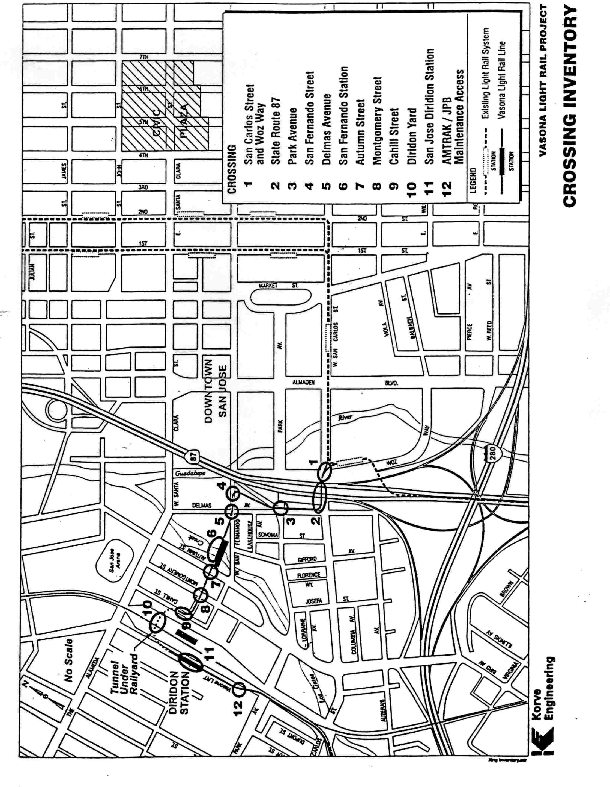
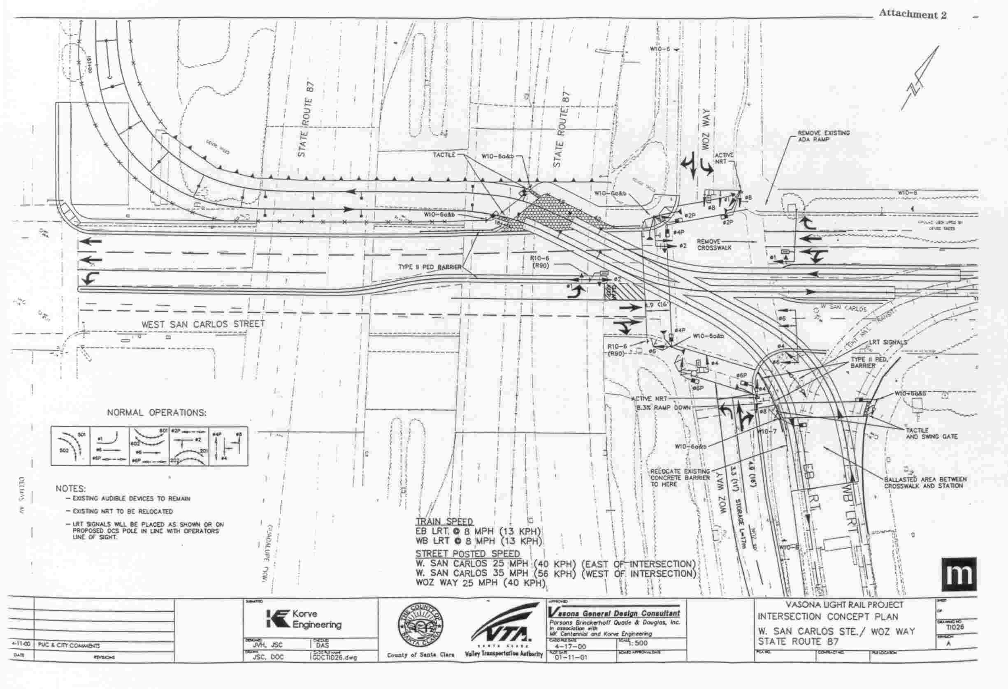
(End of Appendix A)

As part of the project to construct a light rail transit system, the Santa Clara Valley Transportation Authority (VTA) proposes to construct this at-grade crossing by the light rail transit line of the Vasona Light Rail Project in the City of San Jose, Santa Clara County. The Woz Way/West San Carlos Street Intersection, identified as 82D-2.5, shall be further protected as indicated by plans and text contained in the applications and as described below:
a) The southbound traffic movement of Woz Way consists of a left-turn lane and a shared through-right lane. The northbound movement has three lanes: a left turn, through, and right-turn lane. West San Carlos Street has a left turn, through and shared through/right-turn lane for the eastbound movement. The westbound movement for West San Carlos Street has a left turn, two through, and a right-turn lane. The existing Guadalupe LRT alignment changes from east-west direction to a north-south direction just east of the intersection. The Guadalupe LRT alignment travels the center of West San Carlos Street until it turns to the southeast of the intersection and then travels along the east side of Woz Way.
b) The existing traffic signal operations consist of a five-phase operation. The eastbound and westbound left turns have a protected movement while the northbound and southbound left turns are permissive. The existing Guadalupe LRT movements (both directions) are given priority with the westbound left turn traffic signal phase.
c) The traffic signal will be modified to provide eight-phase operation, three of which will be LRT phases. The approaching traffic on the east West San Carlos Street leg can operate with the westbound to southbound or northbound to eastbound LRT movements. The approaching traffic on the west West San Carlos Street leg can operate with the westbound and eastbound LRT movements. During arena events and other special service operations, when LRT movements are eastbound to southbound or northbound to westbound through the intersection, there is no associated phase and all traffic will be stopped.
d) To safely accommodate the LRT and the pedestrian movements on the south leg of Woz Way, the existing right-turn lane will be combined with the adjacent through lane. The westbound West San Carlos Street approach will be modified to provide a shared left-through lane. The stop bars for the eastbound approach will be pulled back to prevent vehicles from encroaching into the LRT dynamic envelope. Active "NO RIGHT TURN ON RED" signs will be placed for southbound and northbound Woz Way traffic. Both of these signs will be activated during arena events and other special service operations, and the northbound Woz Way sign will be activated during all westbound to southbound and northbound to eastbound LRT movements. Active TRAIN APPROACHING icon signs will replace existing TROLLEY COMING signs. Active TRAIN APPROACHING icon signs will also be placed on all the sidewalk approaches crossing the tracks. Pedestrian ADA tactile strips will be placed on all sidewalks crossing the tracks.
(End of Appendix B)
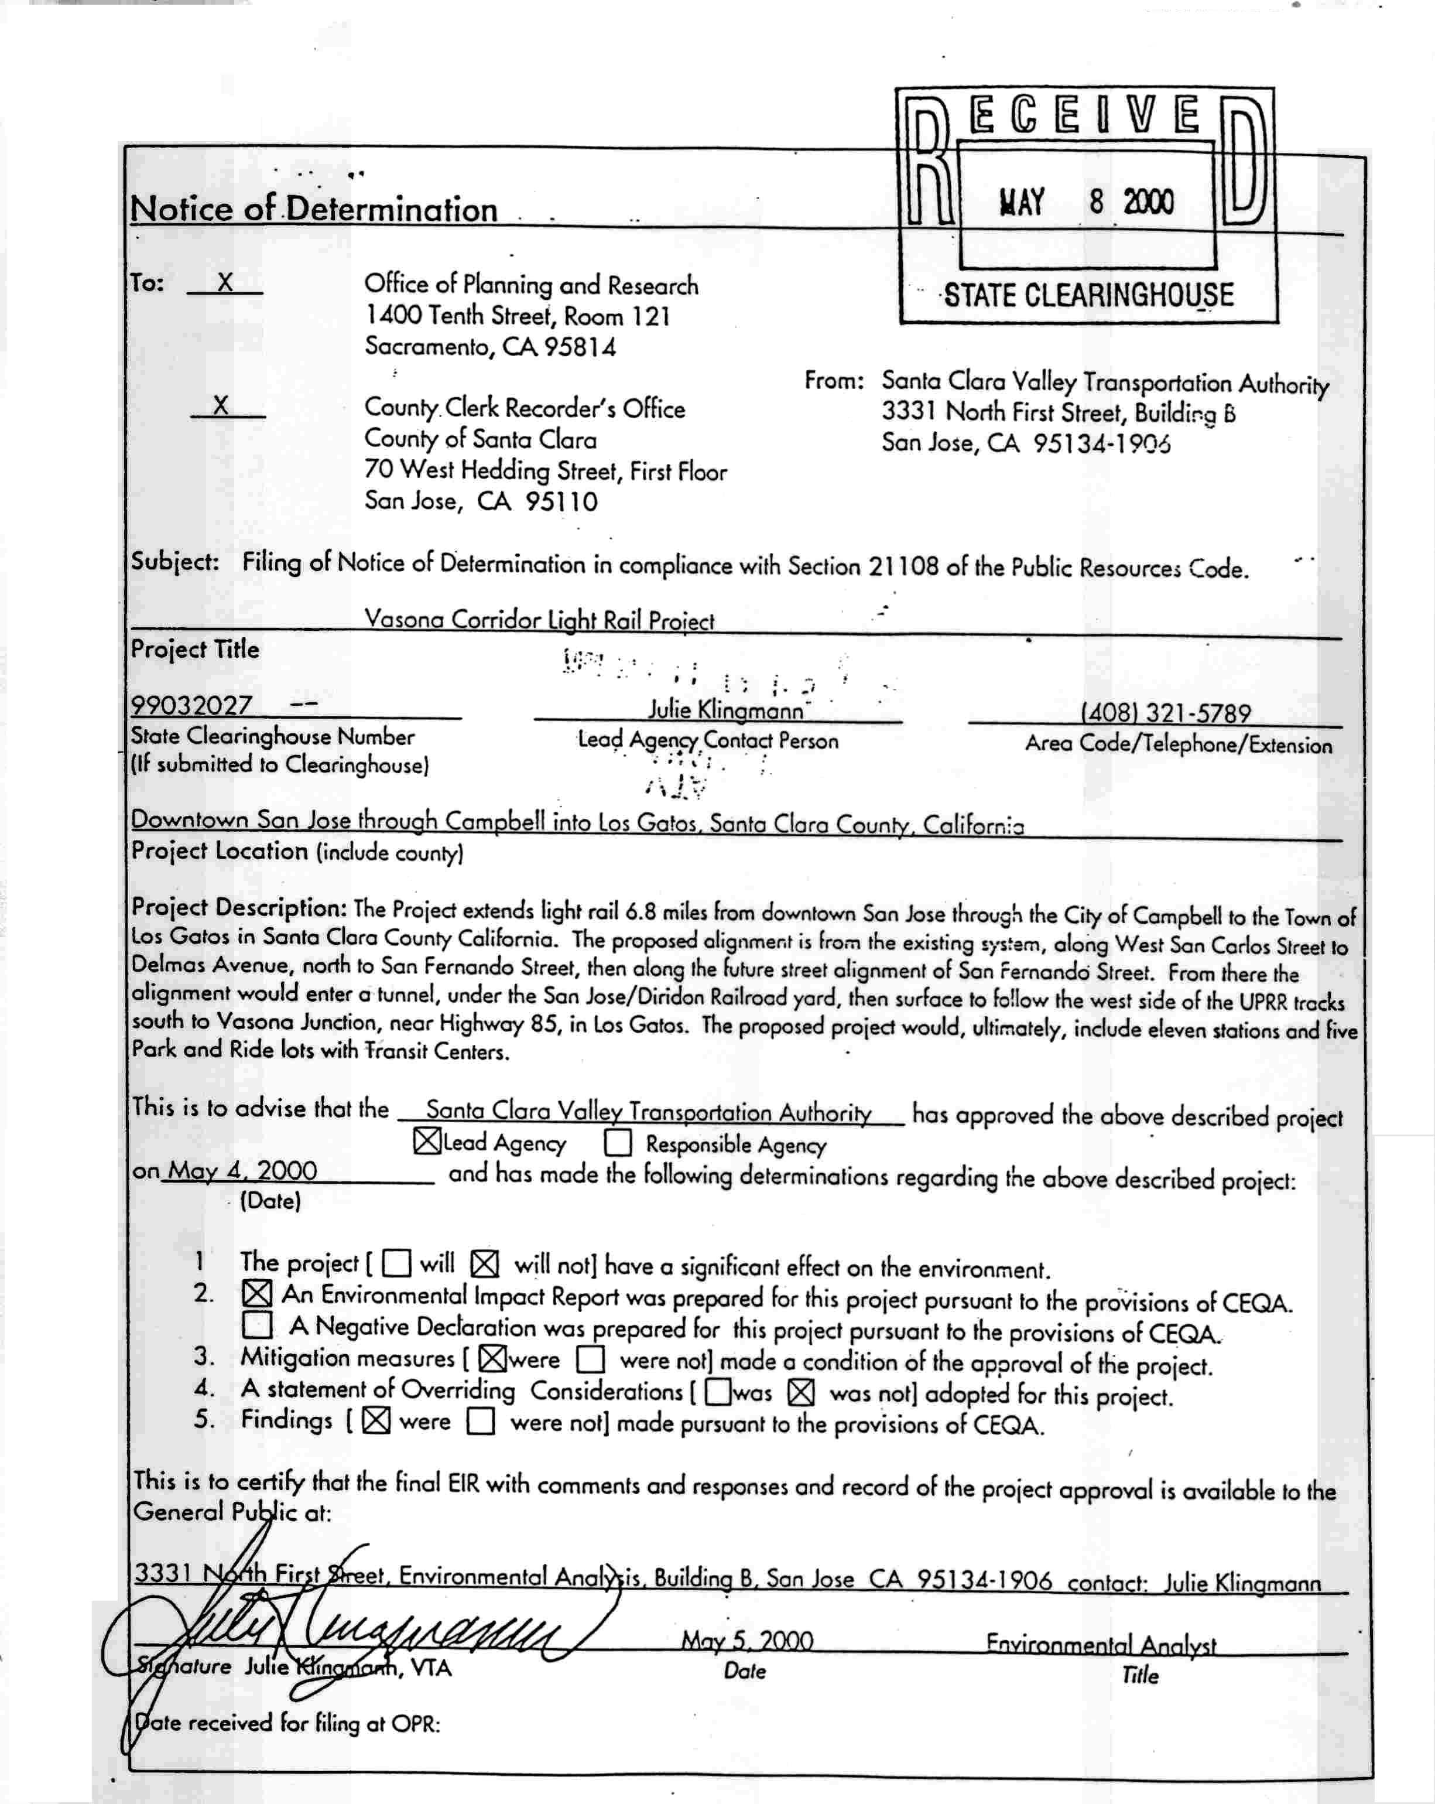
(End of Appendix C)
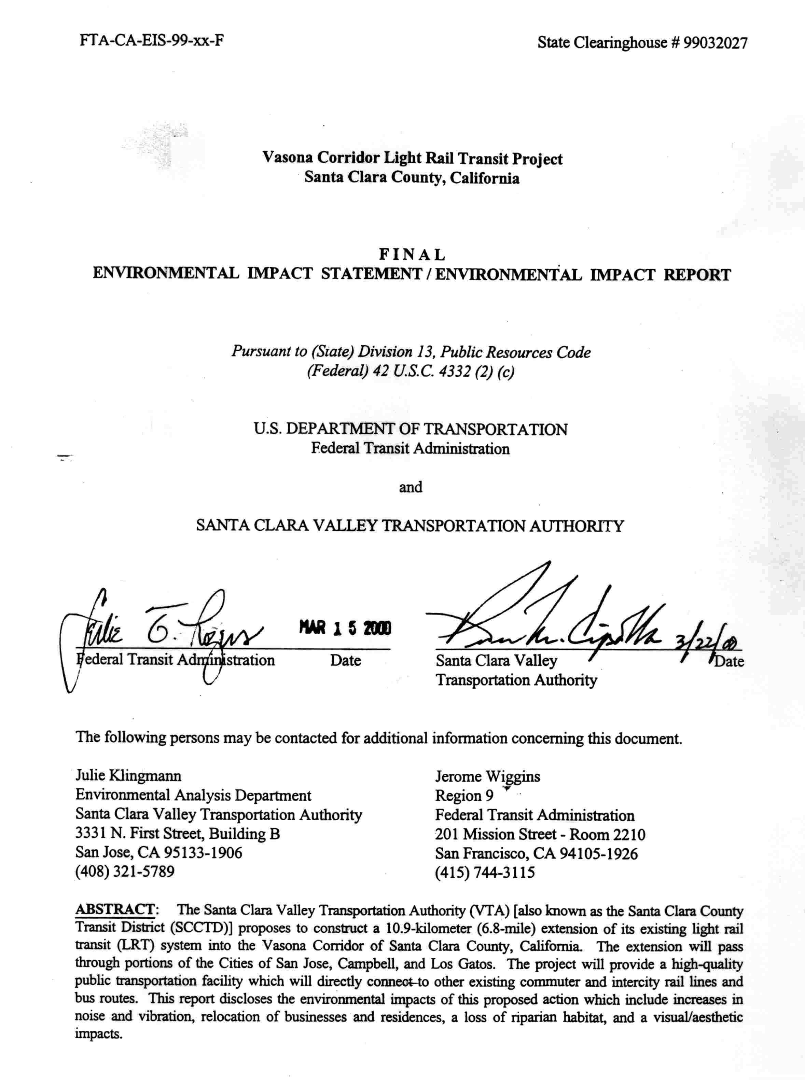
(End of Appendix D)

